# **CTF Topic: Phishing link analysis**

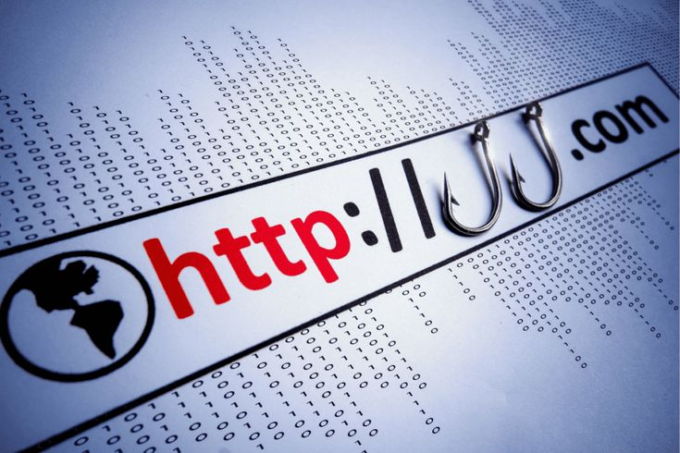

# **1.Introduction**



Phishing attacks often involve sending fraudulent messages that appear to come from a trusted source, such as a bank, email provider, or social media platform. The goal of the attacker is to trick the victim into performing an action that compromises their security.

# **Tools and requirements**

* Easydmarc

# **Scenario**



You are a cybersecurity analyst for a financial institution. Recently, several employees reported receiving suspicious emails containing links. Your task is to analyze one of these links to determine if it is a phishing attempt and gather relevant information to protect your organization.

# **Process to Perform**

Step 1: Open the website easydmarc: <https://easydmarc.com/tools/phishing-url>

Step 2: And scan this link:

<https://attractions-wal-fixtures-definition.trycloudflare.com/login.html>

# **Let’s start the Challenge**

# **Question**

Flag 1: What is the URL status of the given link?

Answer: Suspicious

Flag Captured.

# **Hint**

